APPENDIX A
PHOTOGRAPHS TAKEN DURING JIV AT 12” ENWHE BULK LINE AT ETELEBOU RIGHT OF WAY AT OGBOLOMA COMMUNITY, YENAGOA L.G.A, BAYELSA STATE ON 2IST JULY, 2024.
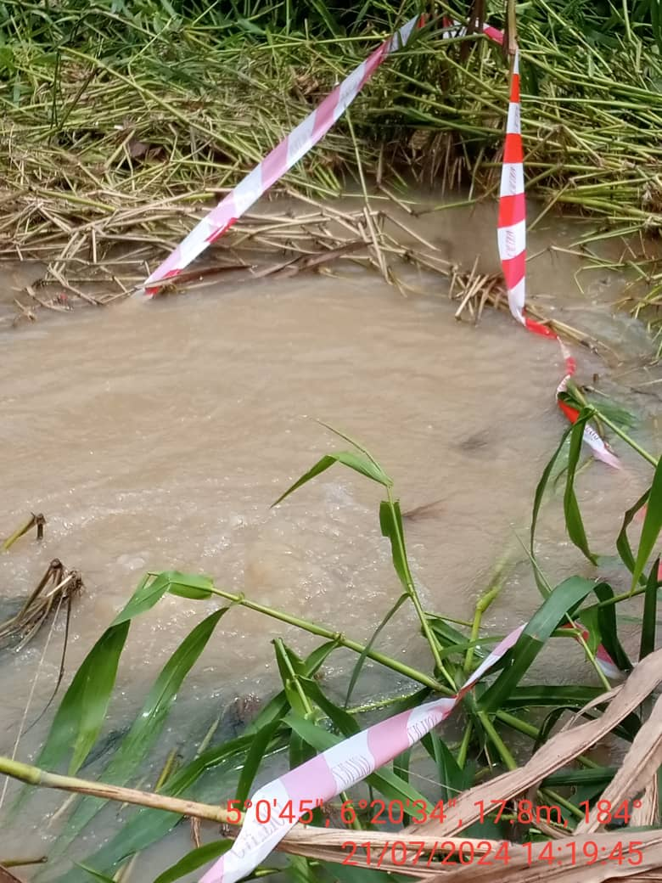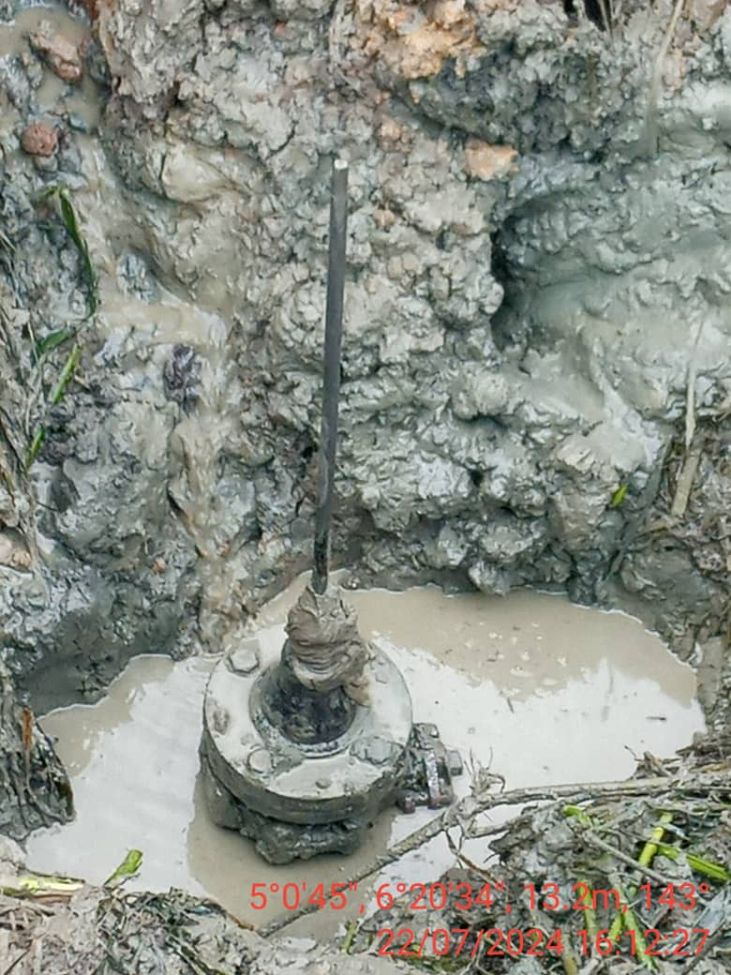
FIG. 1: (L-R) THE INCIDENT POINT BEFORE EXCAVATION.
FIG. 2: 3” FLANGE WITH A ROD INSTALLED AT 12 O’ CLOCK POSITION OF THE PIPELINE FOR POSSIBLE THEFT ACTIVITY.

